**Unit-1**

**Evolution of Mobile radio communication**

**First Generation (1G)**

**Use of frequency modulation for speech transmission.**

**Spectrum is divided using FDMA.**

Drawbacks:

**Security concern:**

It was analog so it was difficult to protect user’s information. There were security concerns. If we use a receiver and tune into the frequency we may be able to hear the entire conversation.

**Spectrum Inefficiency:**

In FDMA a user is given an entire band for transmission and if does not transmit or use the band then it’s a waste of the spectrum.

Various standards of 1G:

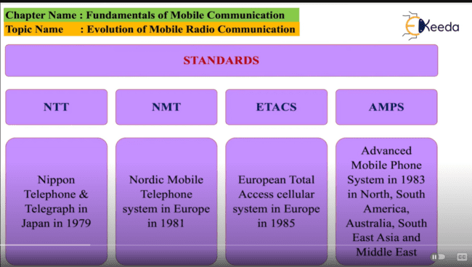

**Second Generation (2G)**

**In 2G, the voice is transmitted using digital modulation techniques and it uses TDMA and CDMA for dividing the spectrum.**

**In TDMA every user is sending the message or voice in time slots.**

**In CDMA every user is divided in frequency using a specific code.**

**Digital modulation means converting the voice signals into digital signals.**

**Digital signals are of the form ones and zeroes and and hence the message could be encoded and hence security could be provided.**

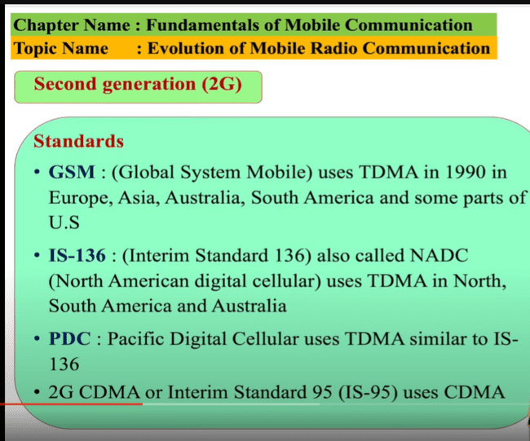

**IS-136 D-AMPS,IS-95 CDMA, GSM**

**2.5G**

**2G provided less data rates for text messaging , browsing etc and hence the 2G was kept same but some add on’s were added on base station to increase the data rate.**

**The mobile phones were given a software update so that the applications could run smoothly.**

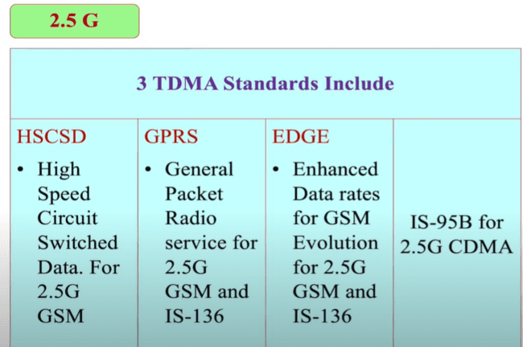

**The above 3 standards HSCSD , GPRS and EDGE are collectively called the 2.5G for TDMA systems.**

**The CDMA for 2G called as IS-95 is called as IS95-B for 2.5G.**

**3G**

As the user’s demand increase the demand for live music , interactive web sessions like video conferencing started increasing.

The ITU (International telecommunication union) decided 2000Mhz frequency is a **global frequency** to be used all over the world hence IMT-2000 was developed.

In the IMT-2000 the devices used in 2G, 2.5G were to be upgraded but the users were divided into CDMA and TDMA.

Thus the CDMA of 2G and 2.5G became the **CDMA 2000.**

The TDMA standards like GSM , IS-136, PDC became **W-CDMA (Wideband CDMA)** or

UMTS (Universal Mobile Telecommunication service).

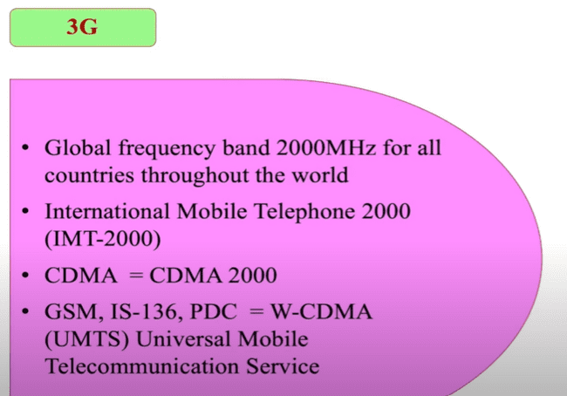

IMT-2000 Introduction:

Uplink frequency used is 1185 MHZ – 2025 MHZ

Downlink frequency is 2110-2200 MHZ

FDD is used for satellite and mobile communication , TDD used for pedestrian and indoor environments.

Vision of IMT-2000

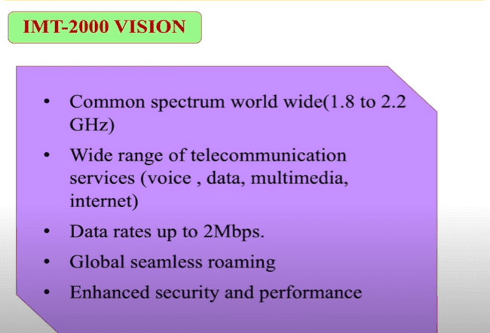

* Data rates of 9.6 Kbps or more for global(mega cell) , 144Kbps or more for vehicular(macro cell) , 384 Kbps or more for pedestrian (micro cell) and upto 2Mbps for indoors(pico cells).

Comparison b/w 1g,2g,2.5g,3g.

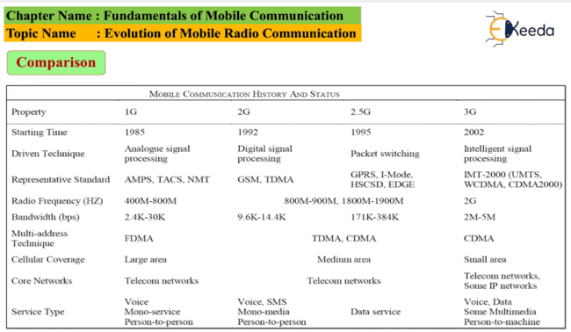

Examples of Wireless communication:

1. Cordless Telephone System:

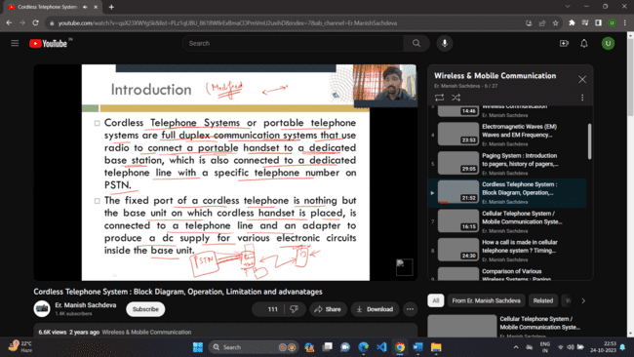

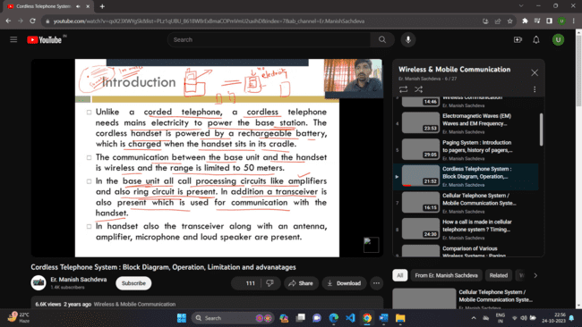

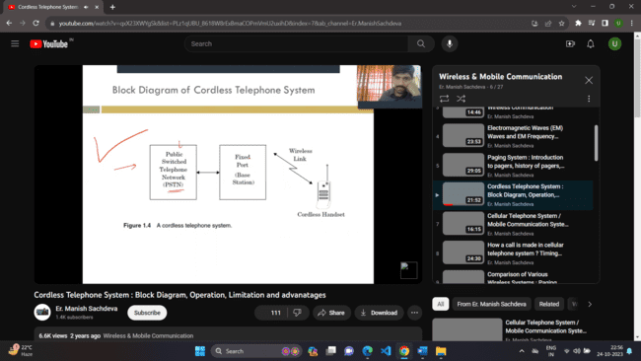

As the base station gets the signal from the PSTN, some base station can also receive it that’s why there is a security issue.

Some extra facts:

The first generation cordless phones were used to a distance of few meters. While the second generation to a distance of 100 meters. In 2nd generation a provision was added with a paging system so that the user could use the paging number to make a contact using the cordless phone. The disadvantage of cordless phone is that it can’t be used outdoor as the connection with the base station can be lost, So the cordless can be used only indoor.

2.Paging system:

**Pagers:**

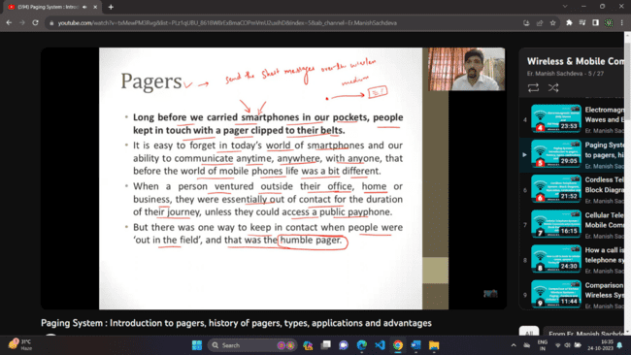

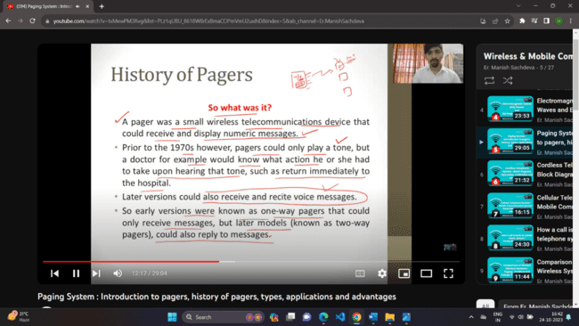

Motorola coined the term pagers and the first successful pager was Motorola’s pageboy 1 launched in 1974. In year 1994 there were 61 millions pager users worldwide , the phones were launched but were big and expensive so slowly people turned towards phone which eventually led to downfall of pagers but still in some sectors pagers are used.

**Paging System:**

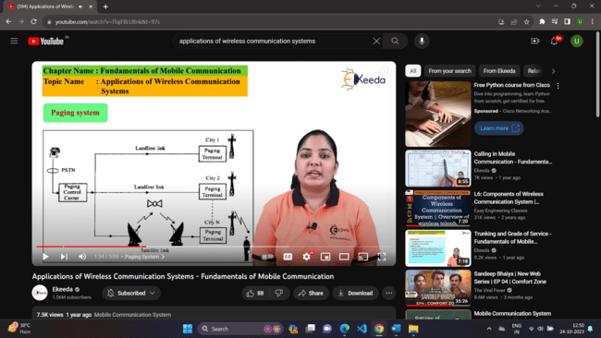

Paging is a brief message sent.

* Pager is a Simplex Communication Device. Paging Systems are one way communication systems that send messages to a subscriber. Message can be numeric or alphanumeric or voice message.
* Paging Systems are used to notify a subscriber of the need to call a particular telephone number or to travel to a location to receive further instructions. In modern paging systems, news headlines, faxes can also be sent.
* A message is sent to a paging subscriber via the paging system access number with a telephone keypad or modem. **The issued message is called a "Page‟.**
* There are two types of paging systems:
* The coverage area of a **simple paging system** ranges from 2 to 5 km while a **wide paging system** can have a worldwide coverage area. Whenever a sender wants to send a message to a receiver he dials the 10 digit pager number of receiver through his telephone.
* Then this call is accepted by the operator present in the paging control centre to whom the receiver pager number and the message to be sent has to be sent.
* Then the operator will broadcast the message and the receiver paging number to all the paging terminals or the base stations.
* Then a particular base station under the area where the receiver is present will transmit the message to the receiver pager. Then the receivers pager device will receive all messages and will verify whether the sender number is stored in its memory or not.
* If it is stored then the pager device will give beep which indicates the receiver that a message is sent by sender to his pager and the message will be displayed in the LCD.

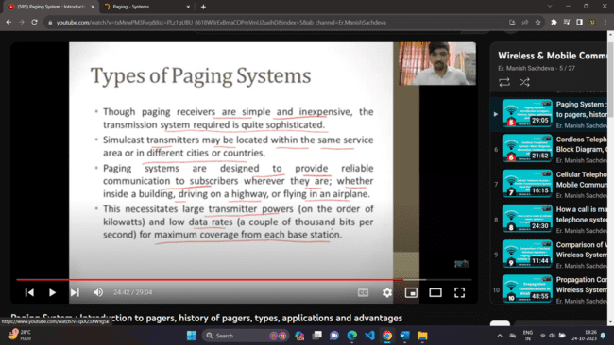

Each subscriber or pager has a unique pager number or paging system access number.

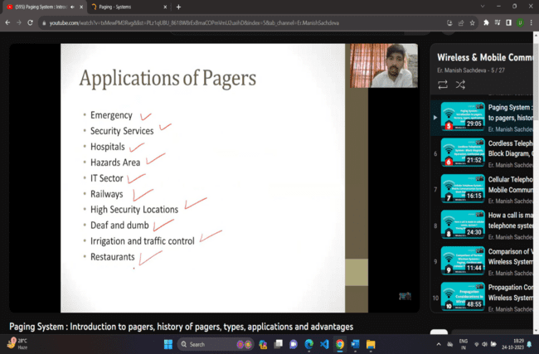

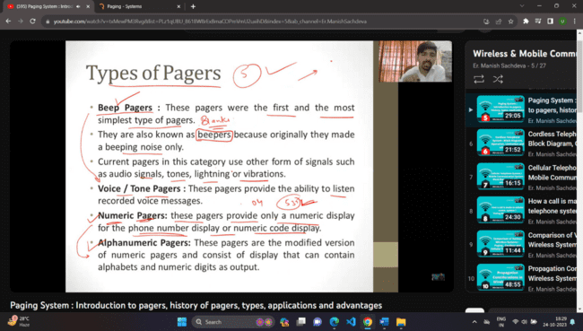

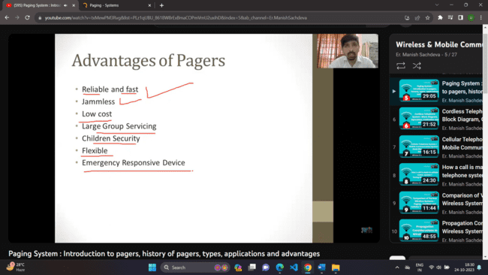

Cellular systems:

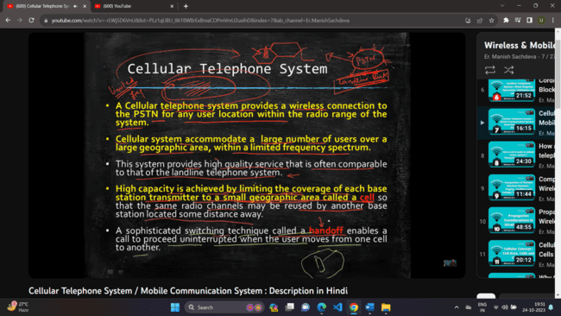

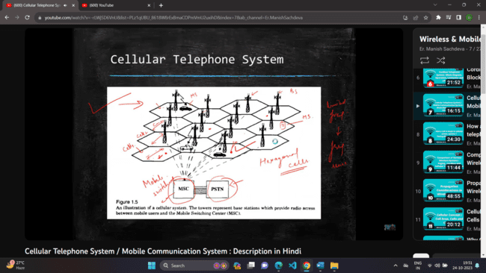

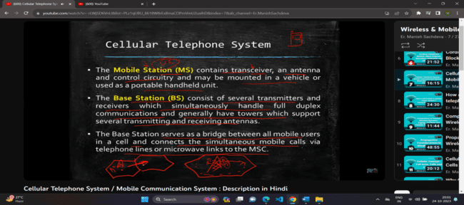

The Different cells or base stations are connected with wires and MSC is connected to all base stations with wires/satellite. The handsets and base stations are connected wirelessly within a cell.

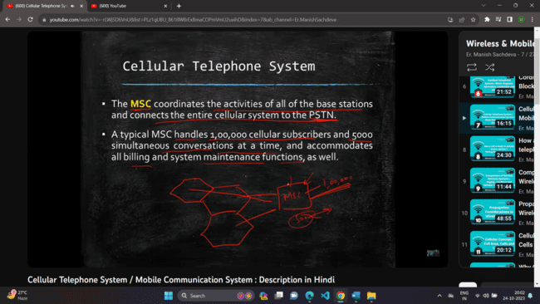

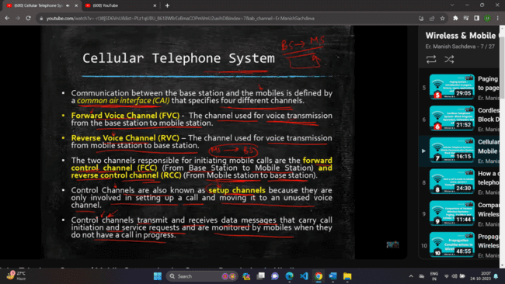

Difference b/w various examples of WC:

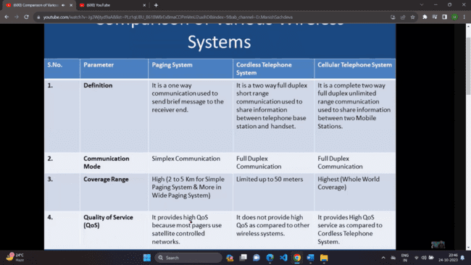

Note: The wide paging system can range upto a state or country.

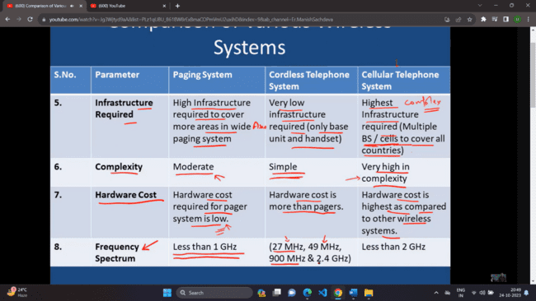

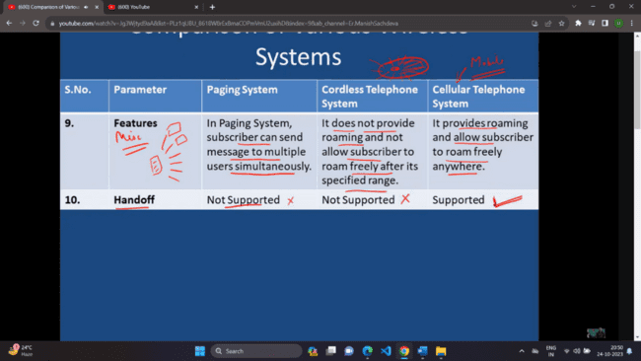

**PCS architecture (Personal communication system)**

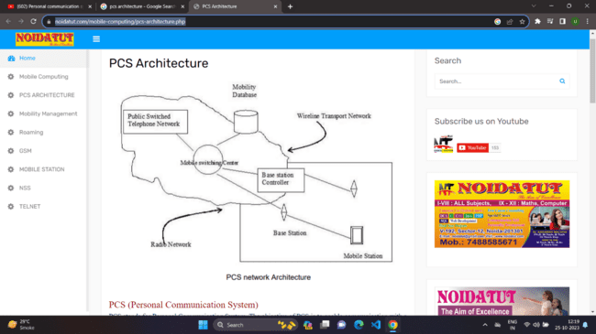

**Components in PCS architecture:**

There are 2 parts **radio network** and **wireline transport network.**

1. **Base station:** The base station provides signal to the mobile station, the mobile station or handsets are connected to some base station.
2. **Base station Controller:** It manages, controls and coordinates allthe base stations in its area. Foreg: If a mobile station is connected to a base station which has less efficiency the base station will be switched for that mobile station. It also manages the data flow and security of the base stations.
3. **Mobile switching center (MSC):** In the older days, analog calls traveled across copper wires, and each call needed its own dedicated wire to connect a call. Operators would sit at a switchboard and literally connect the wires to connect two phones to a call.It acts as a mediator between the sender and the receiver. When the sender calls a person the call goes to the MSC which direct it to the nearest base station where the person is roaming and then creates the virtual connection between the sender and receiver of the call. Thus the security threats get reduced as there is no intermediate person but the MSC.
4. **The Mobile database:** All the user information, vouchers information, the subscription information is stored inside the database.
5. **PSTN:** It is the aggregate of worlds telephone systems. It is a combination of underground wires, cellular systems, switching centers which facilitates the the call from your destination to recepients destination.

**Mobility Management:**

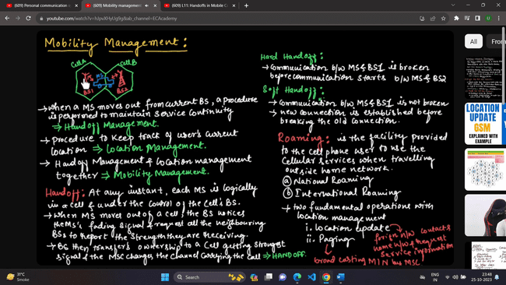

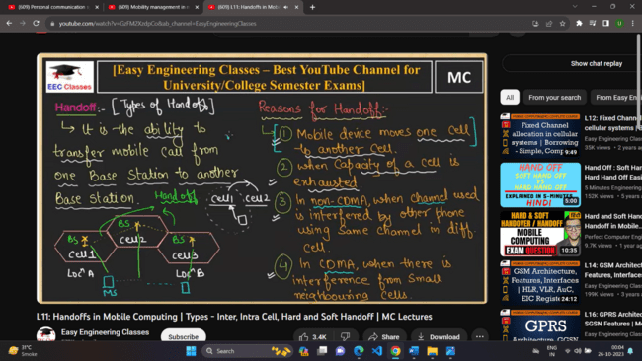

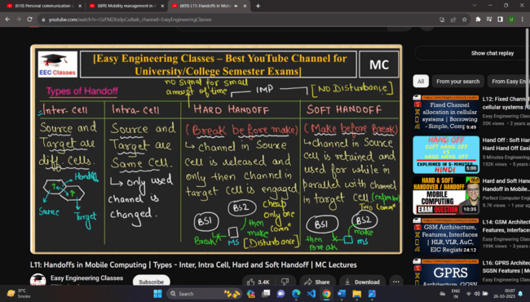

**Multiple access techniques:**

It allows multiple users to use the bandwidth simultaneously either in frequency, time or code.

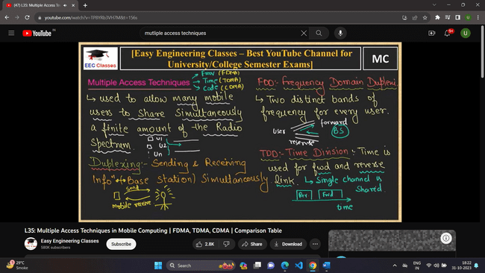

Frequency division duplexing:

It allows 2 distinct frequency bands/channels for every user, the first channel for forward communication and the second channel for reverse communication.

Time division duplexing:

It divides the available channel/ frequency band in different time slots for forward and reverse communication.

**Multiple Access Techniques**

FDMA

Available bandwidth is divided into different frequency bands/channels and each user/station is assigned a different frequency band/channel which belongs to the user all time.

* Each user is assigned a unique frequency.
* During the call period no other user can use the channel of another user.

**Features:**

* If a channel is not used then it remains idle and hence the bandwidth is wasted.
* FDMA allows a limited number of users only , for eg: a radio spectrum can be divided into thousand frequency bands / channels then only 1000 users will be able to use the spectrum.
* FDMA is less complex than other methods of multiple access

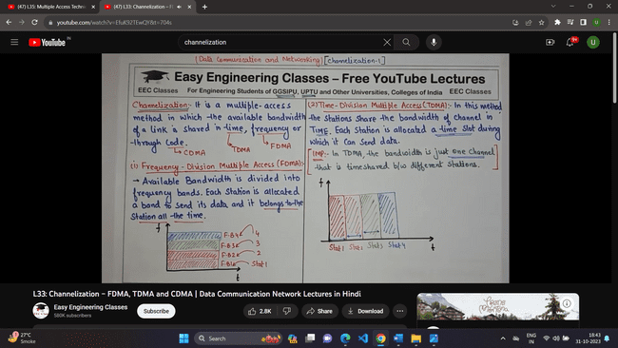

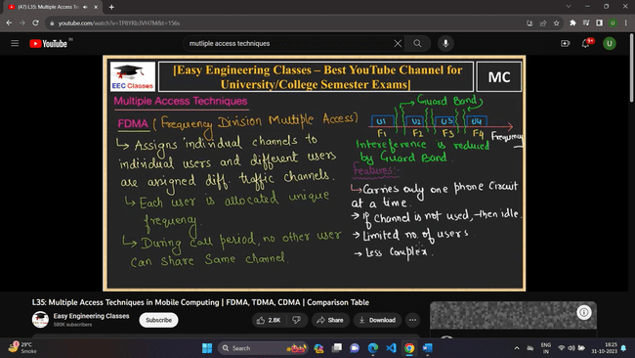

Between the different frequency spectrums guard bands are there to reduce interference of the bands/channels.

TDMA

Available bandwidth or radio spectrum is divided into different time slots. Each user/station is allocated a time slot during which he can send or receive the data.

In TDMA there is one frequency bandwidth /channel which is divided into multiple time slots.

 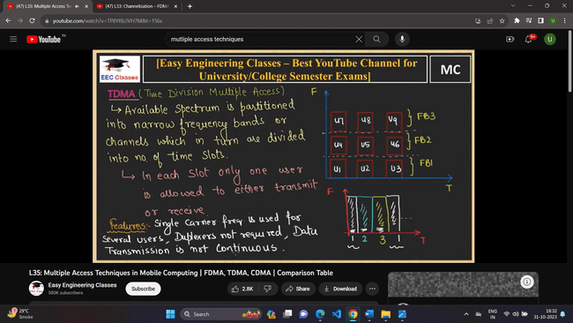

In above diagram different users will send data in different slots , eg: in slot 1 user 1 , in slot 2 user 2 , in slot 3 user 3 and in slot 4 user 1 again and so on.

In advanced version of TDMA the bandwidth is divided in frequency bands which are in turn divided into different time slots which increases the capacity of the spectrum.





Duplexers are not needed as different users send data in different time slots and hence the transmission is not continuous and hence there is latency.

CDMA

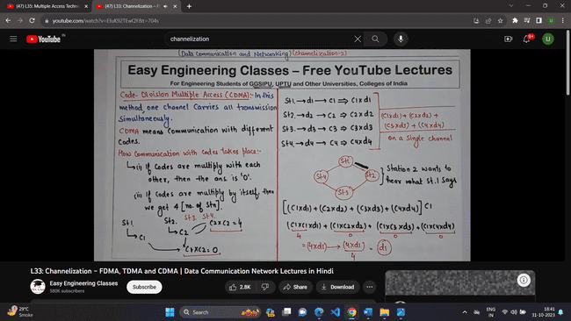

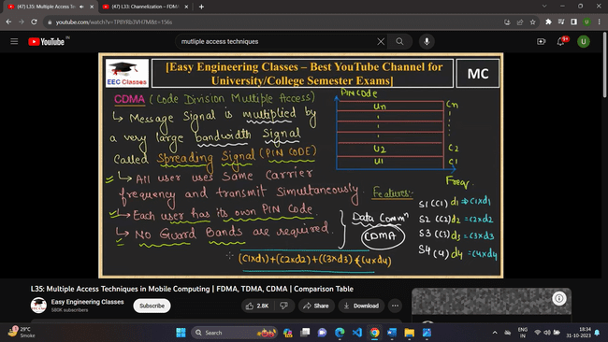

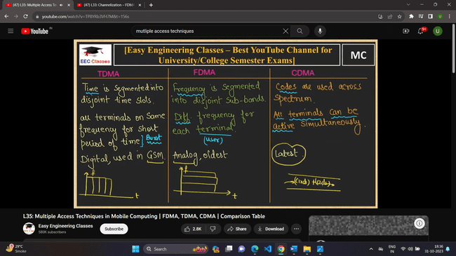

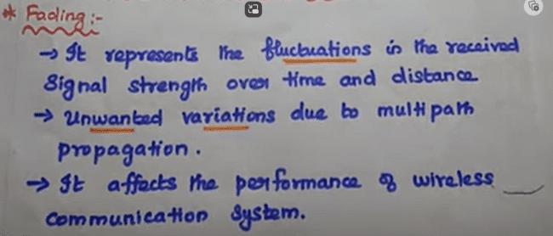

Note: After the above definition draw the multipath propagation diagram.

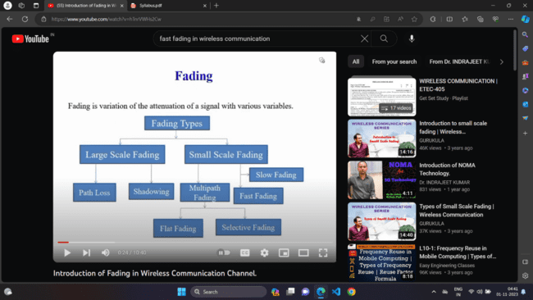

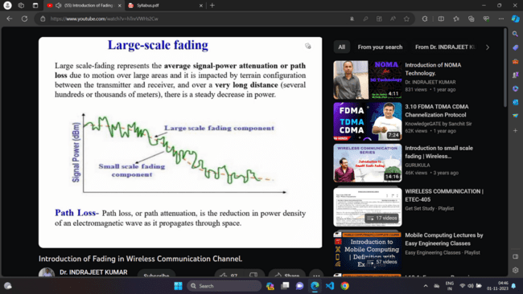

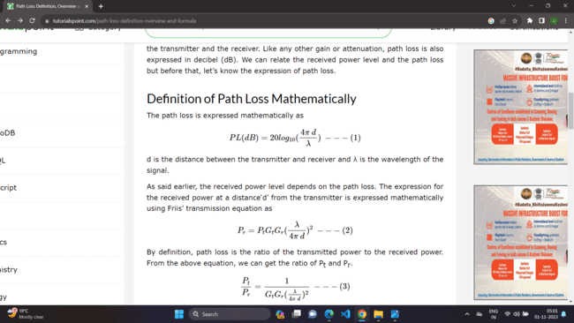

d = distance b/w transmitter and receiver

lambda = wavelength of the signal

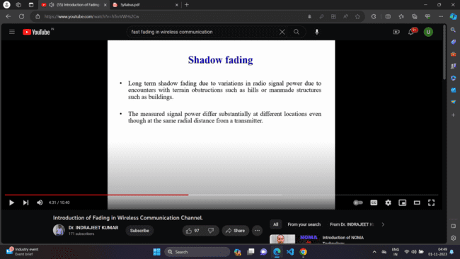

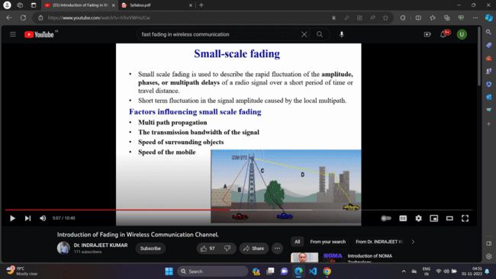

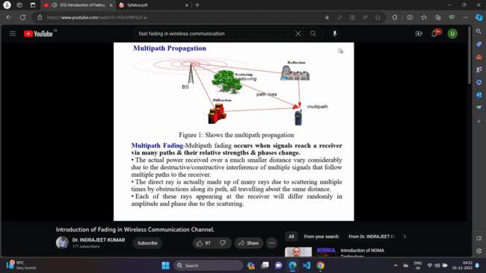

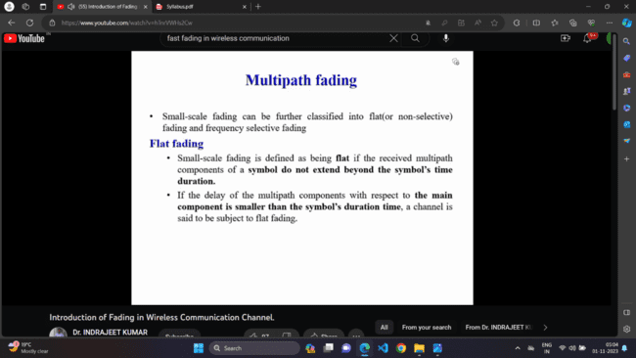

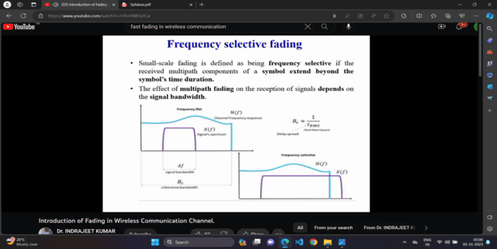

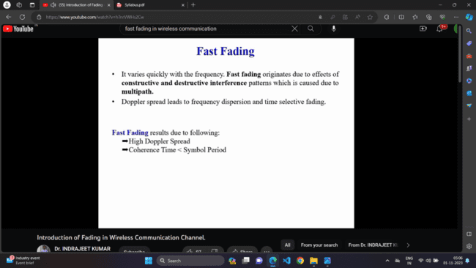

* Channel variation is faster than baseband signal variation
* Higher Doppler spread
* Bandwidth of transmitted signal < Bandwidth of Doppler spread Bs<BD
* Tc<Ts (coherence time < symbol period)
* Varies quickly with frequency

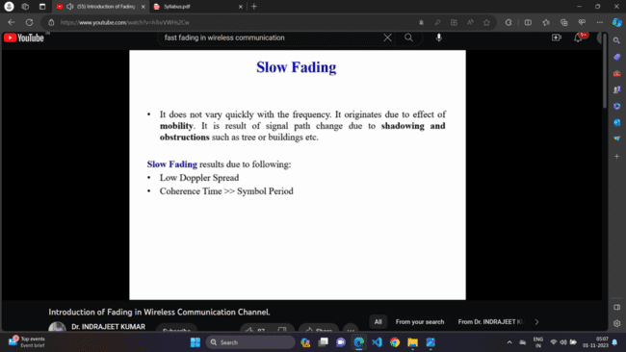

* Channel variation is slower than baseband signal variation
* Lower Doppler spread
* Bandwidth of transmitted signal > Bandwidth of Doppler spread Bs>BD
* Tc>Ts (coherence time > symbol period)
* Doesn’t vary quickly with frequency

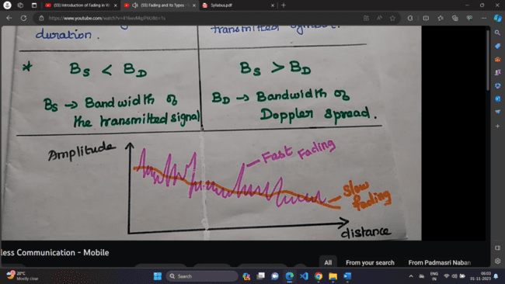

Rayleigh distribution

In mobile radio channels the Rayleigh distribution is used to describe the statistical time varying nature of the received envelope of the fast fading signal or the envelope of the multipath component.

All the frequency components behave in a similar manner, there is no peak amplitude of single frequency component or no peak amplitude in the envelope.

Below is the Rayleigh distribution which shows that the envelope is having similar amplitudes and no frequency component is having a peak amplitude.

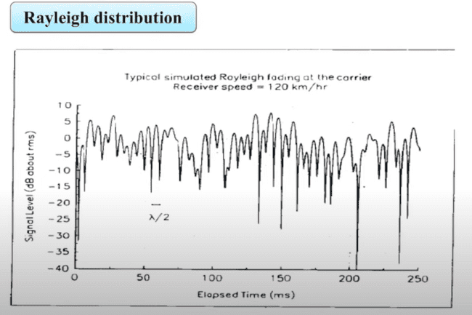

This is possible because there is no line of sight of path because if when there is a line of sight of path between the transmitting and receiving antenna and no obstruction between them then the receiver will receive the maximum amplitude which means the envelope will have the peak frequency component which is absent in Rayleigh distribution.

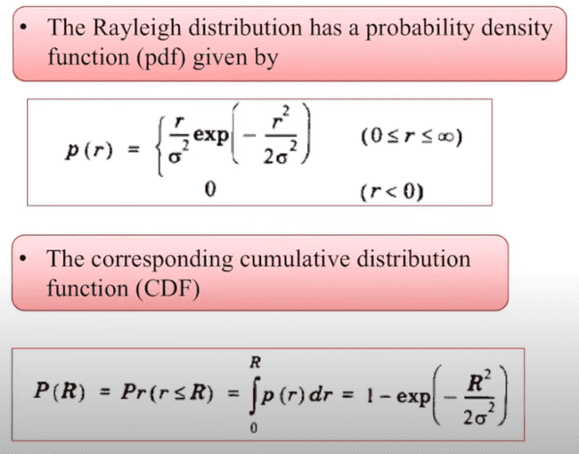

Ricean Distribution

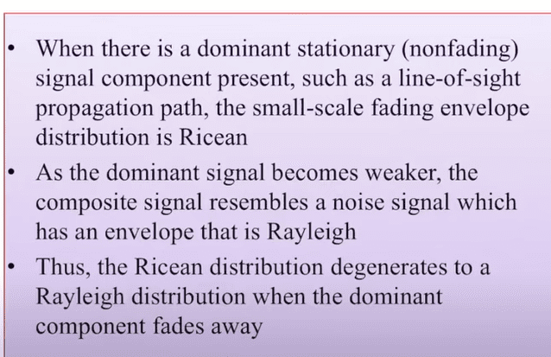

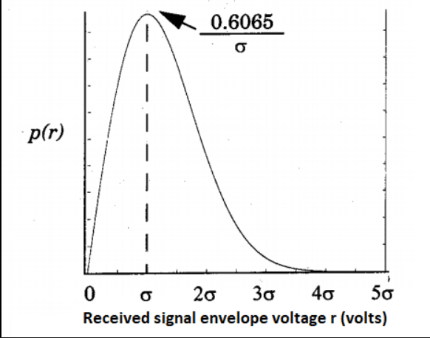

Rayleigh probability distribution function(pdf)

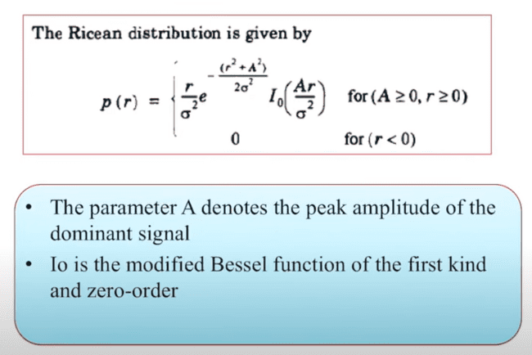

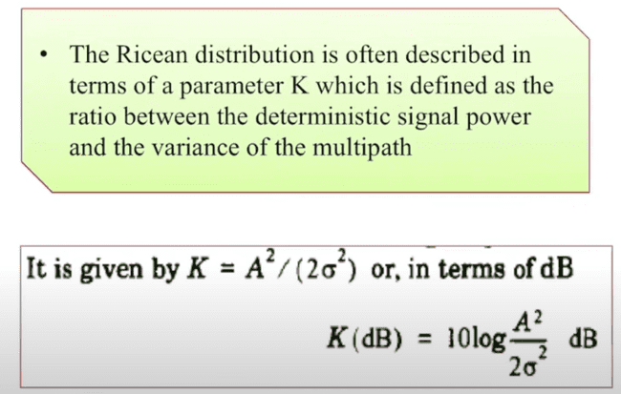

A= peak amplitude , A2= power , sigma2 = variance

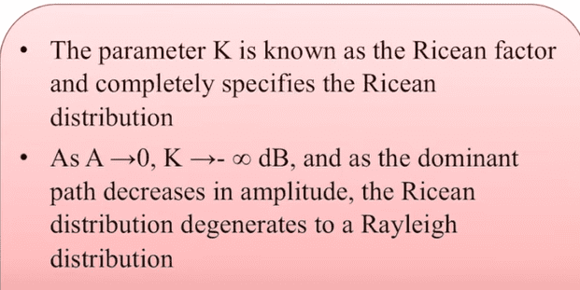

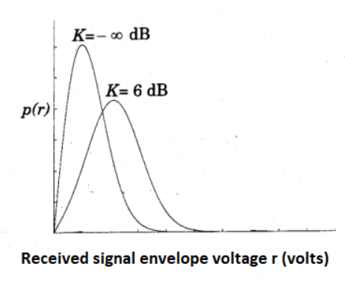

Ricean Probability distribution: K=-∞ dB (Rayleigh) and K=6 dB for K>>1

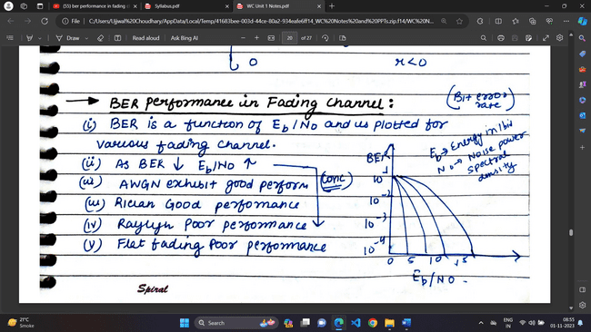

Diversity Modeling

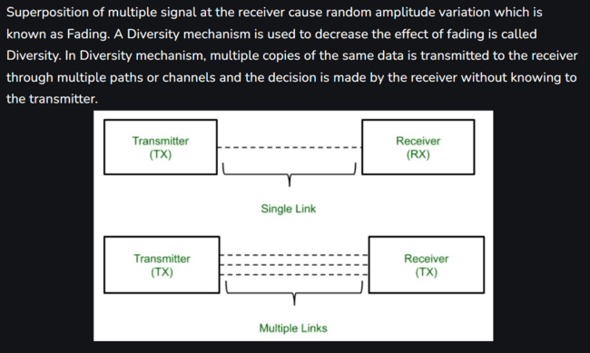

**Diversity techniques** are used in wireless communications systems to primarily to improve performance over a fading radio channel and wireless link improvement at low cost.

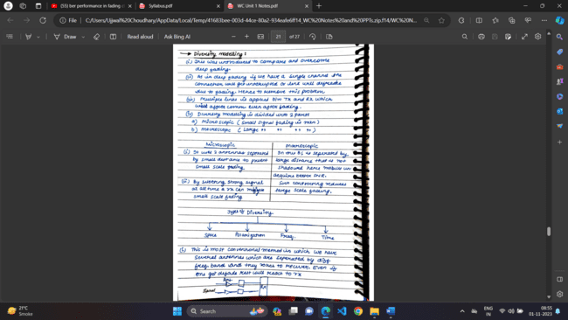

Microscopic diversity techniques

* Used to mitigate small scale fading.
* We use two antennas separated by small distance, one of the 2 antennas always receive a strong signal and the other one a faded signal , the strong signal is picked up everytime.

Macroscopic diversity techniques

* Used to mitigate large scale fading.
* There are many base stations separated by a long distance and the base station which is not shadowed chosen by the receiver to receive the signal. This base station provides a better signal to noise ratio to mobile station.

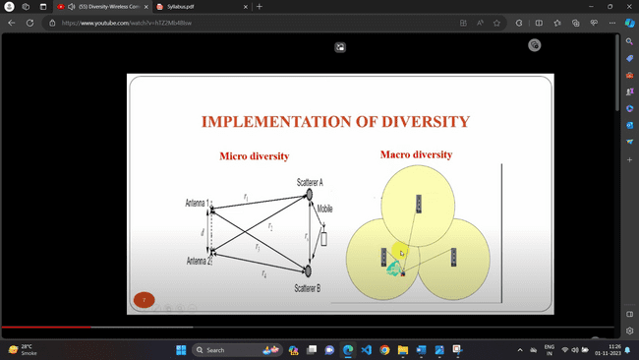

Types of Diversity:

Frequency diversity:

In frequency diversity, the same signal is transmitted through different carrier frequencies or different channels having different frequencies. The difference between the frequencies of the carriers must be equal to at least the coherent bandwidth. The coherent bandwidth is that particular bandwidth with which when the signal is transmitted, the distortion becomes evident at the receiver.

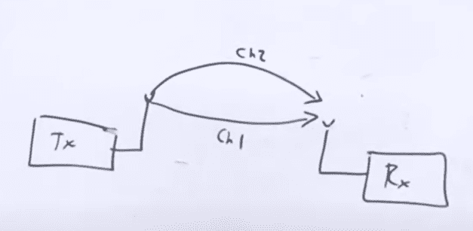

Time diversity:

The signals is sent by the transmitter to the receiver repeatedly at regular intervals. The difference between the times of transmission must be greater than the coherent time which is the time duration of a signal at which the distortion becomes evident at the receiver. The time interval depends on the fading rate, and increases with the decrease in the rate of fading.

Ex: CDMA receiver – RAKE receiver.

Space/spatial diversity:

It is an antenna diversity.

Mutiple antennas are be used either either at transmitter or receiver or both.

The antennas must be separated by a distance of tens of wavelengths.

The signals being transmitted must be decorrelated otherwise no use of diversity technique.

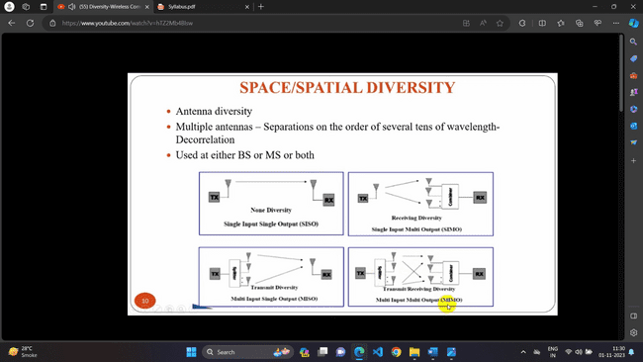

Types of space diversity:

1. Selection diversity: The highest instantaneous SNR branch is connected to the demodulator. Antenna signal themselves could be sampled and the best one sent to a single demodulation. Hence the signal with best SNR is sent to receiver.
2. Feedback diversity: N-signals are scanned until one is found to be above a predetermined threshold and that signal is sent to the receiver. Signal is received until it falls below threshold, scanning process is again initiated.
3. Maximal ratio combining:

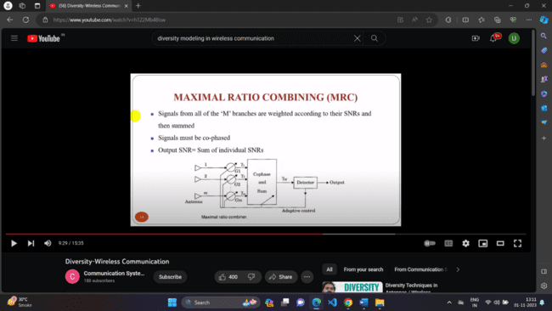

Advantage: The O/P signal is acceptable even if none of individual signals are acceptable. This is best known linear diversity combiner.

1. Equal gain combining technique:

Signal from each antenna is co-phased.

Make use of energy in all branches.

Performance is marginally inferior to MRC and superior to selection diversity

Polarization Diversity: Here, the electric and magnetic fields of the signal carrying the information are modified and many such signals are used to send the same information. Thus **orthogonal type of polarization is obtained**.